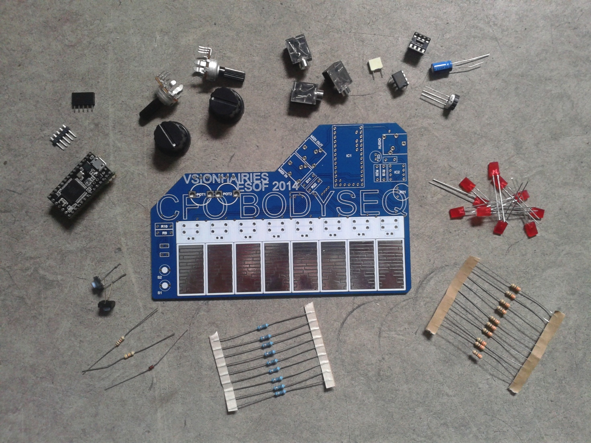

check that you have all parts (refer to BOM – bill of materials)

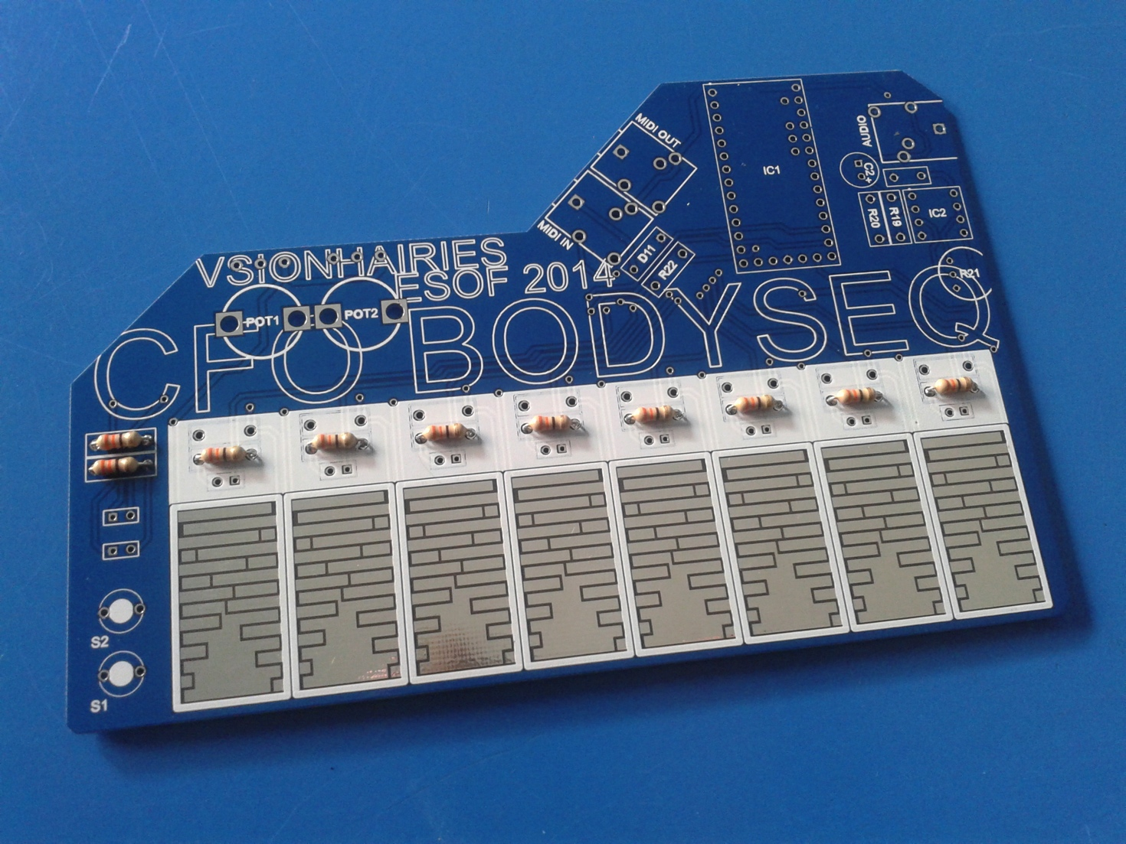solder R1 - R10 (120 ohm resistors)

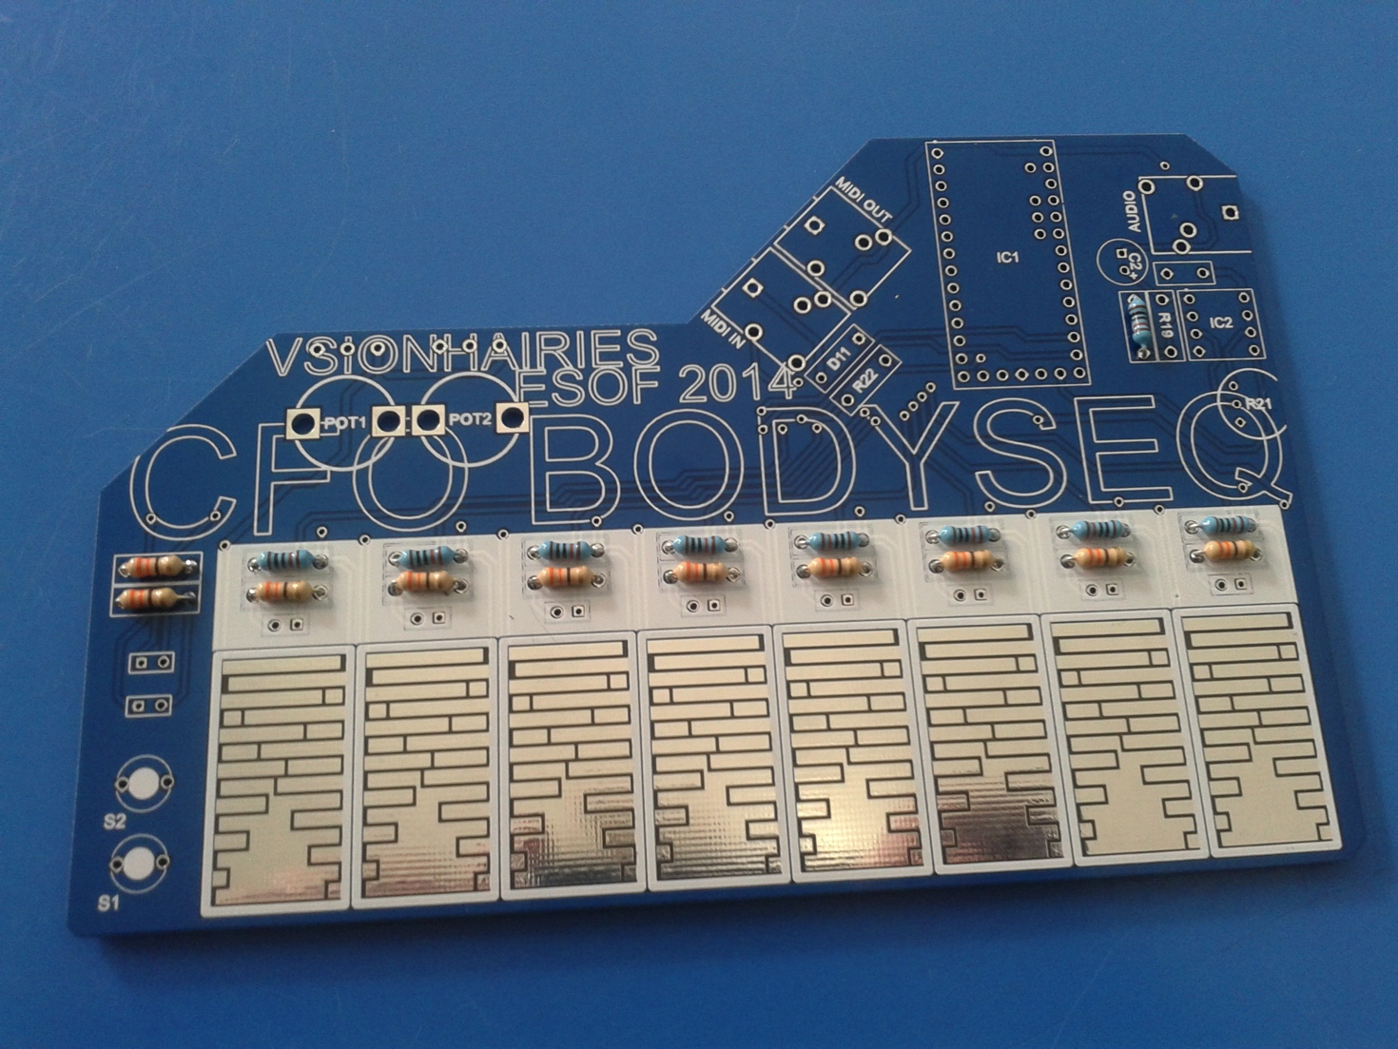

solder R11-R18 and R20 (10k resistors)

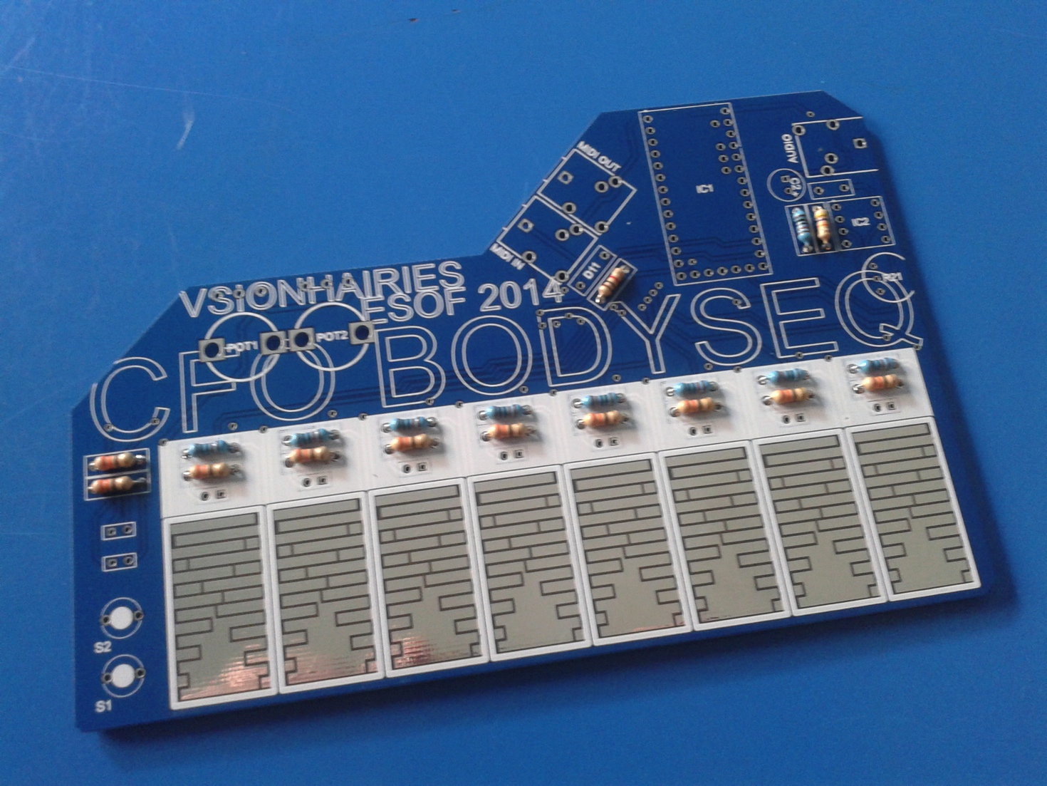

solder R19 (10k resistor) + R22 (1k resistor)

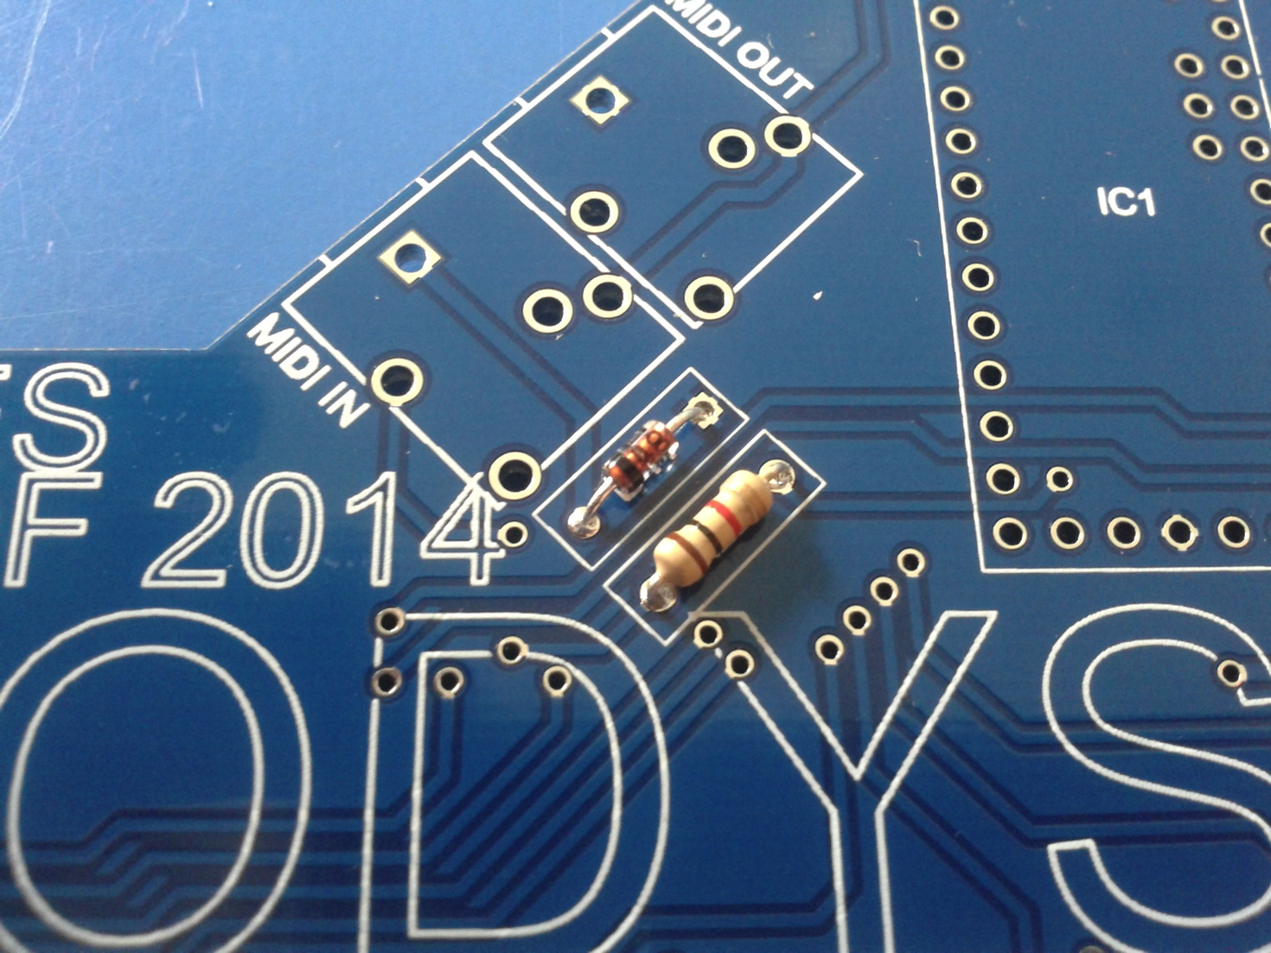

solder diode D11 (NB: make sure you have the polarity right / turn it the right way)

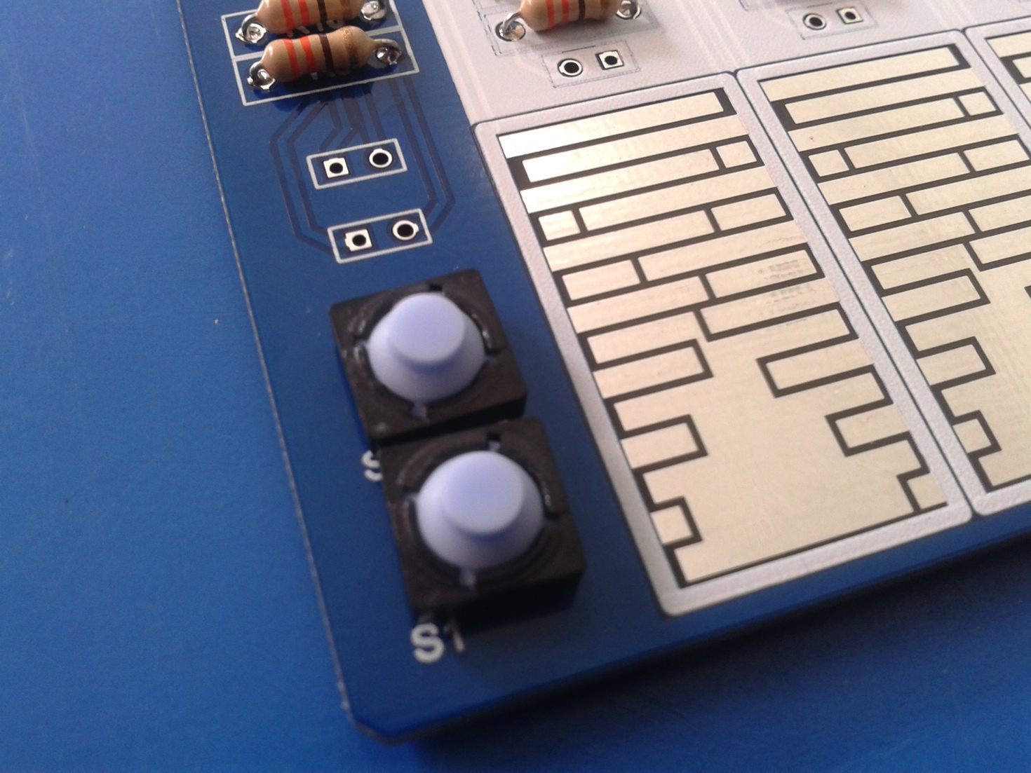

solder tactile switches S1+S2

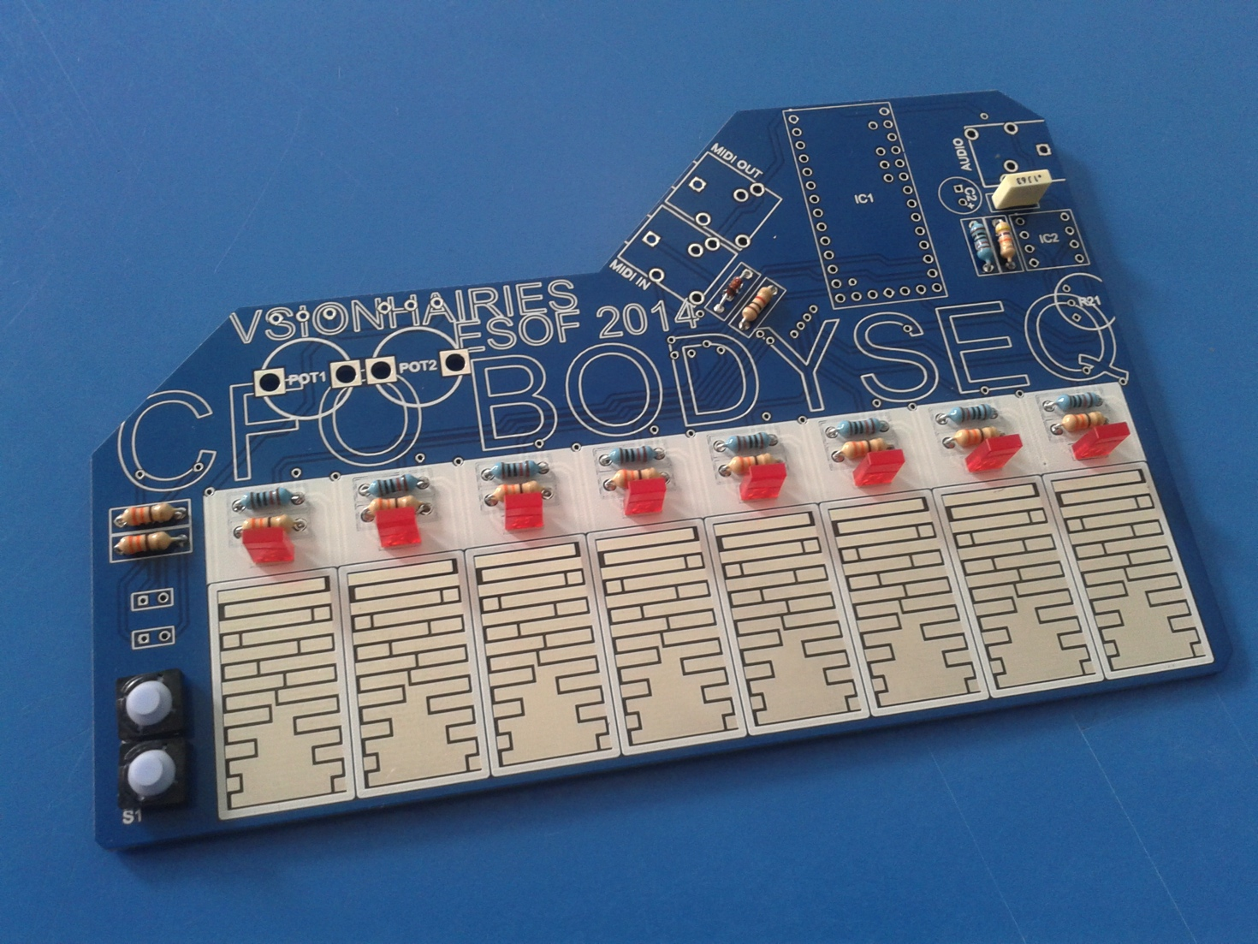solder C1 (100 nF capacitor)



solder step sequencer LEDs D1-D8 (NB: polarity: plus is RIGHT leg)

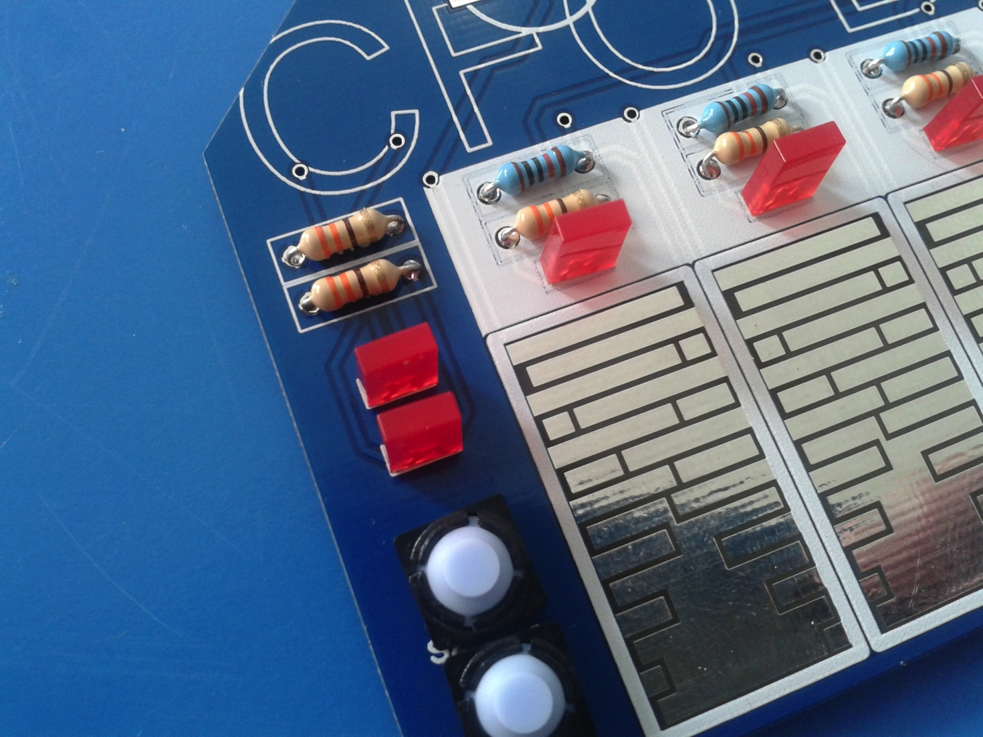

solder LEDs D9-10 (NB: polarity: plus is LEFT leg)

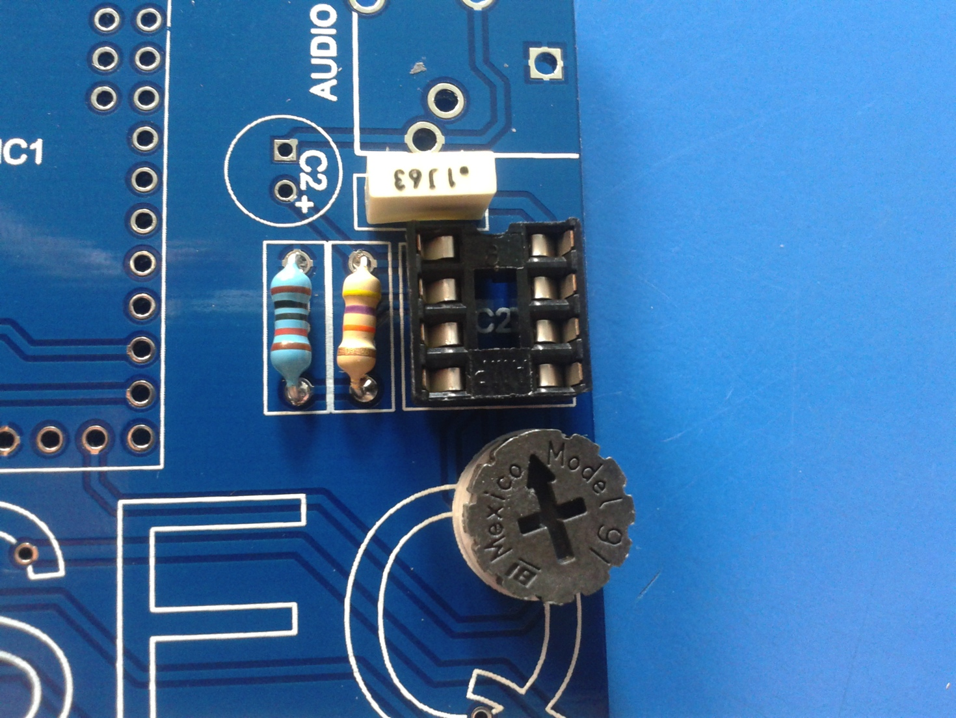

solder thumbwheel potentiometer R21 + IC socket IC2 (NB: make sure the IC socket is oriented upwards: the marker/indent should be on top)

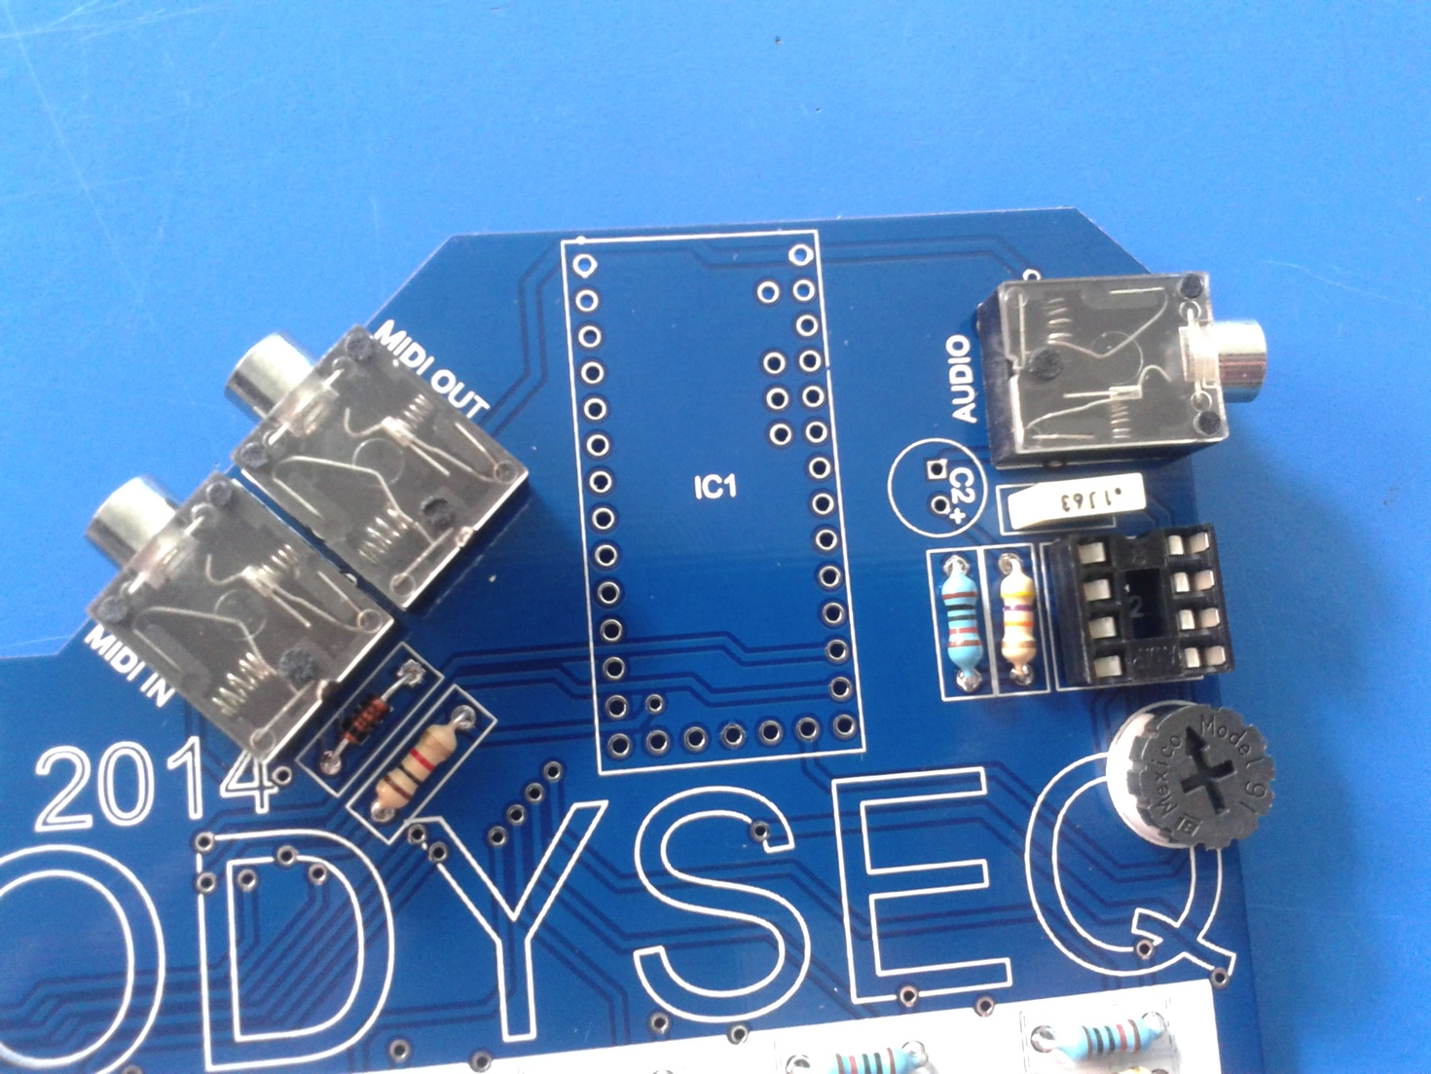

solder mini jacks AUDIO, MIDI IN, MIDI OUT

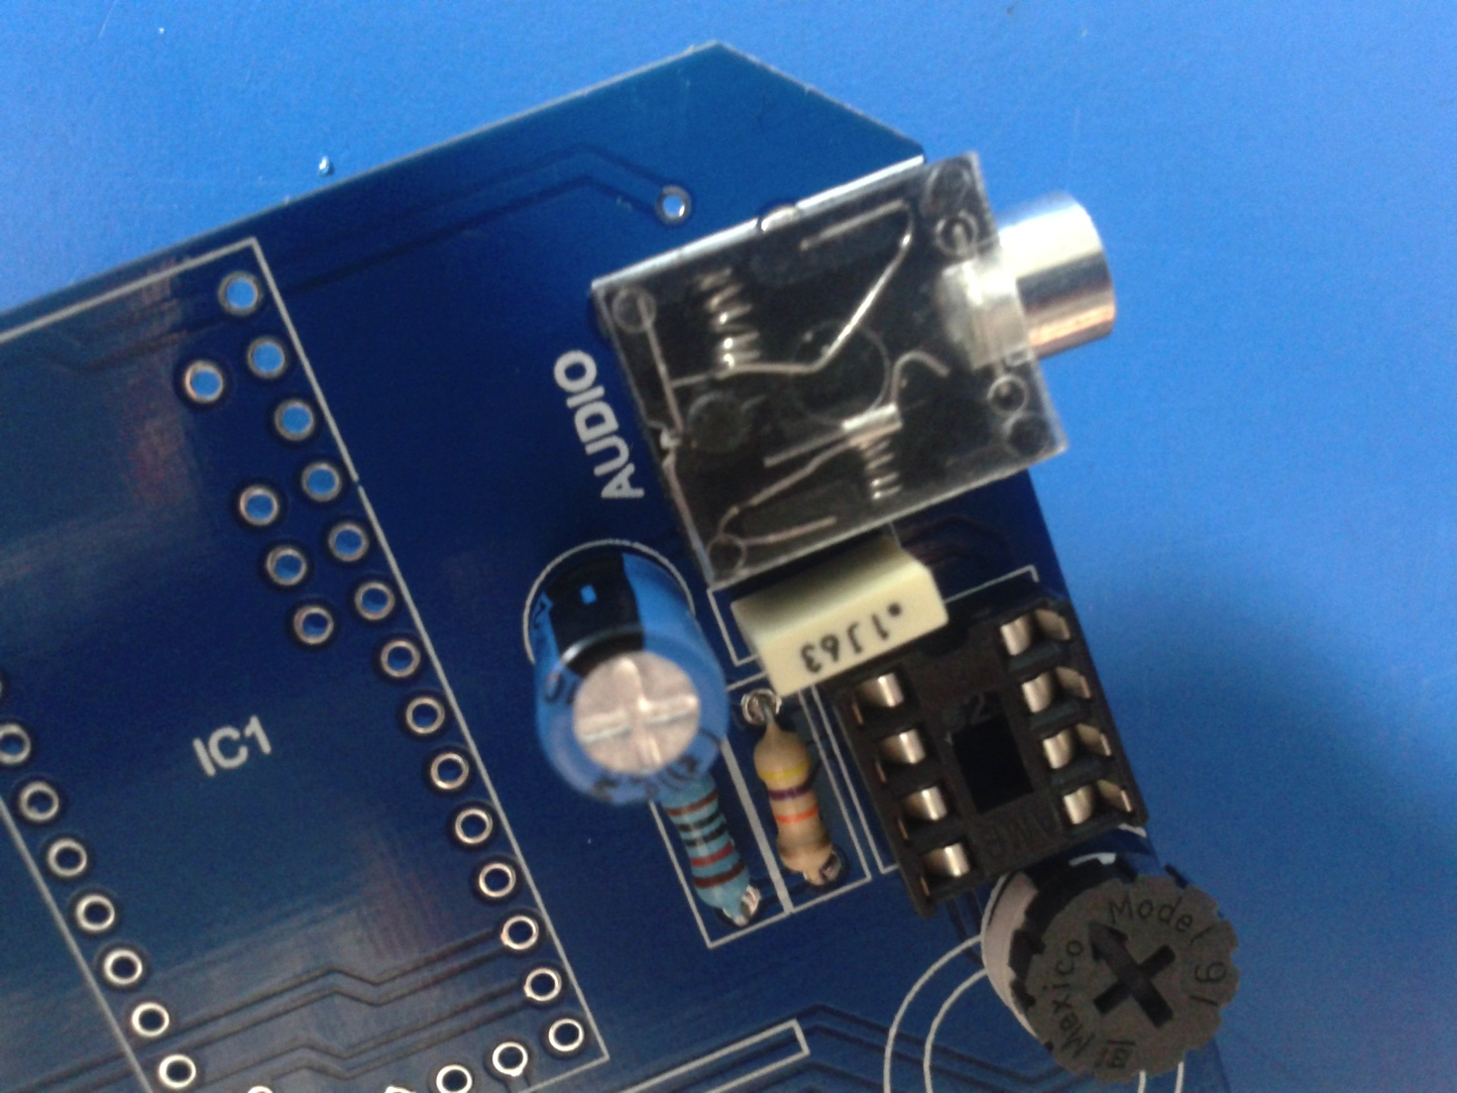

solder C2 (XX radial capacitor, NB: make sure you have the polarity right / turn it the right way)

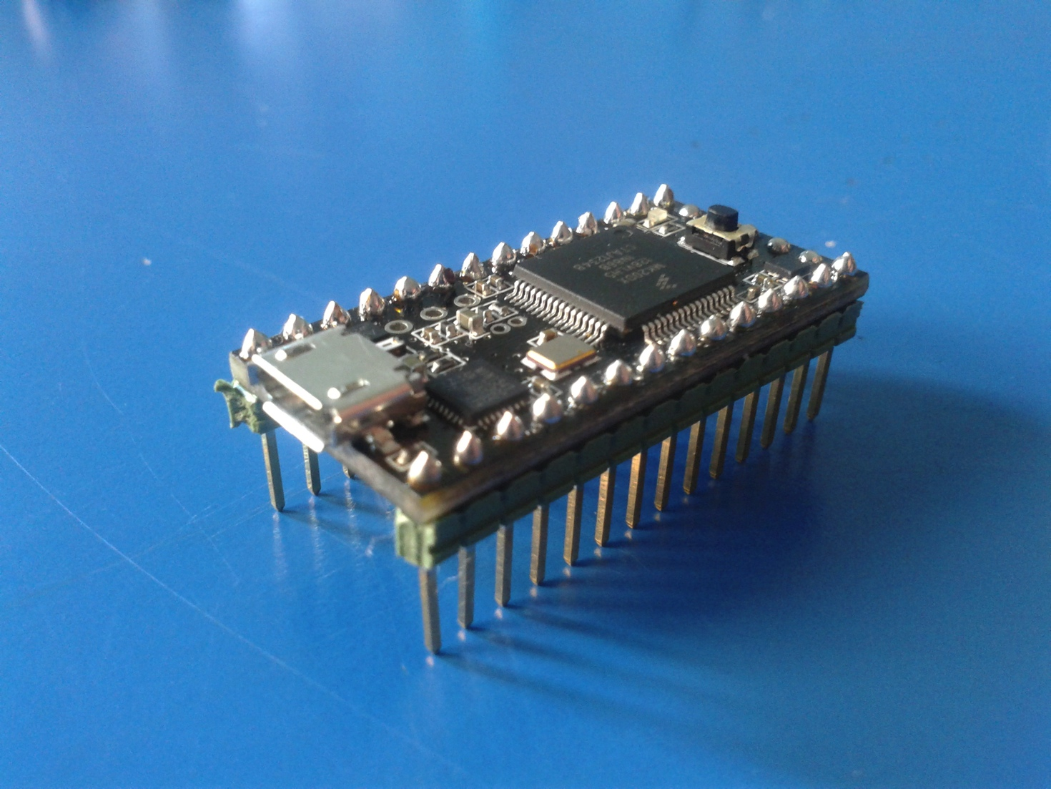

solder male pin headers to teensy 3.1 microcontroller

***PIC PENDING:***

solder female pin headers to CFO BODYSEQ

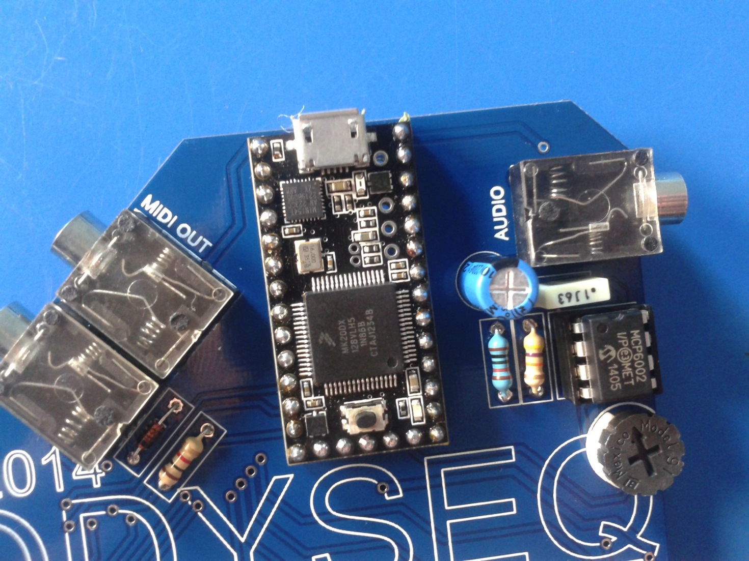

attach teensy 3.1 and IC (both facing upwards)

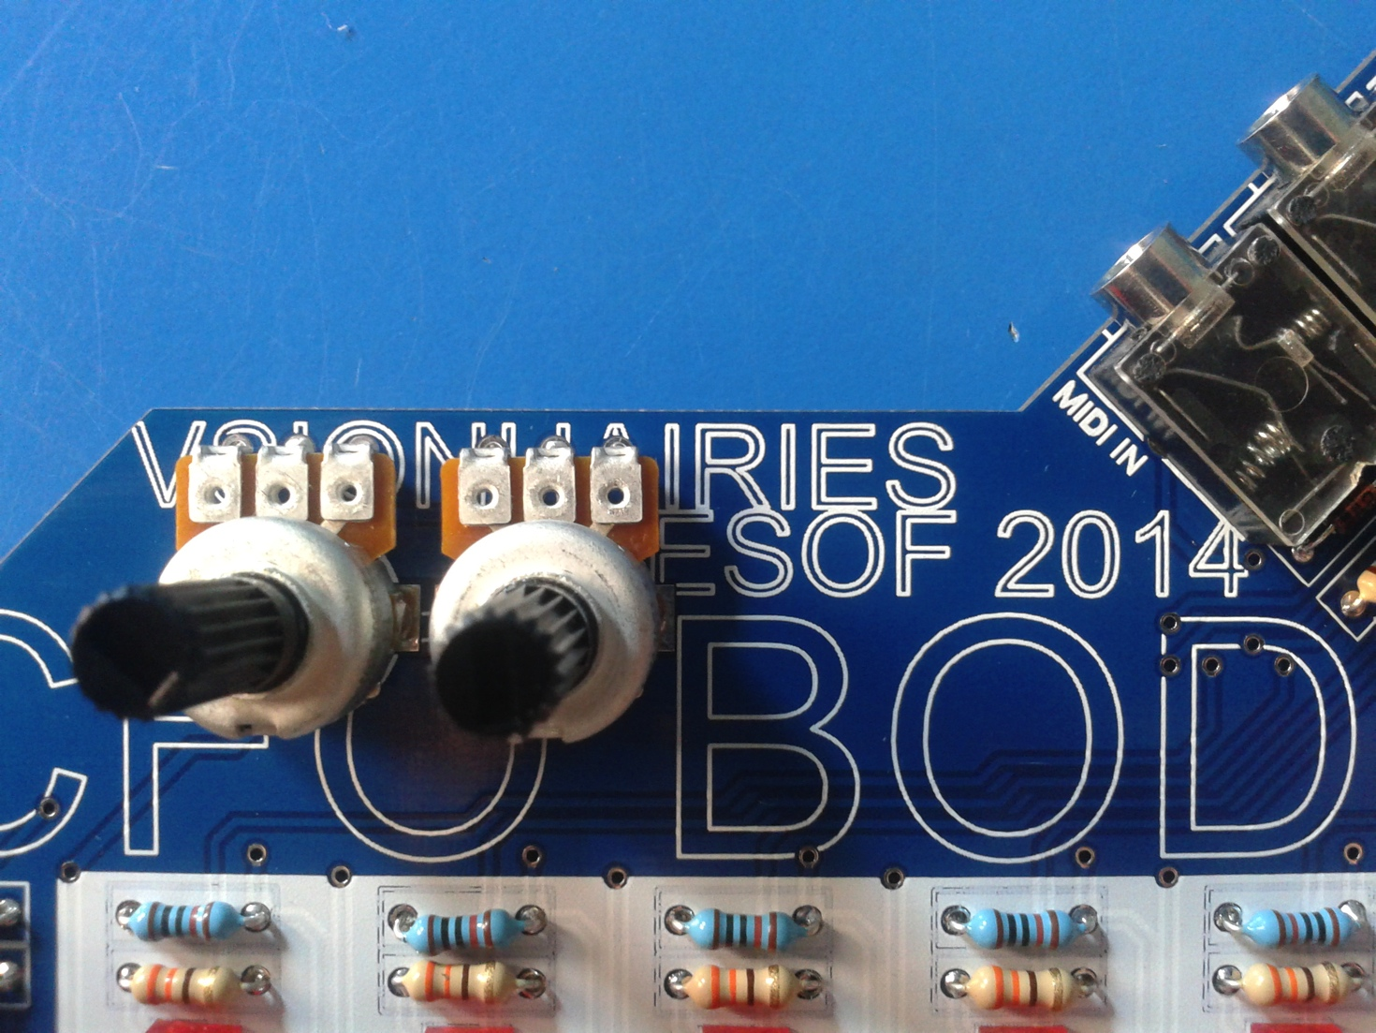solder POT1 + POT2

***PIC PENDING:***

attach knobs to potentiometers



get dressed. its ACID TIME!